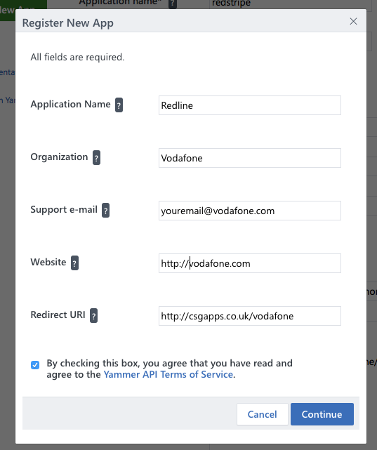

Add an app using the following details, feel free to change the name, organisation, email and website to whatever you feel it needs to be. For now leave the Redirect uri as http://csgapps.co.uk/vodafone/ (You can change this later when we have a better url)

You should them be presented with the following page

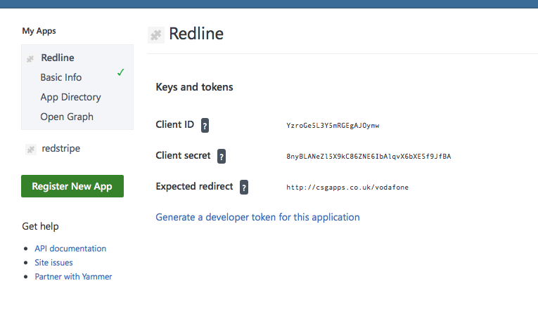

We need the client ID and secret to add to the app.

If you click on the **Basic Info** menu item and add the <http://csgapps.co.uk/vodafone/> to the javascript origins box and hit save.

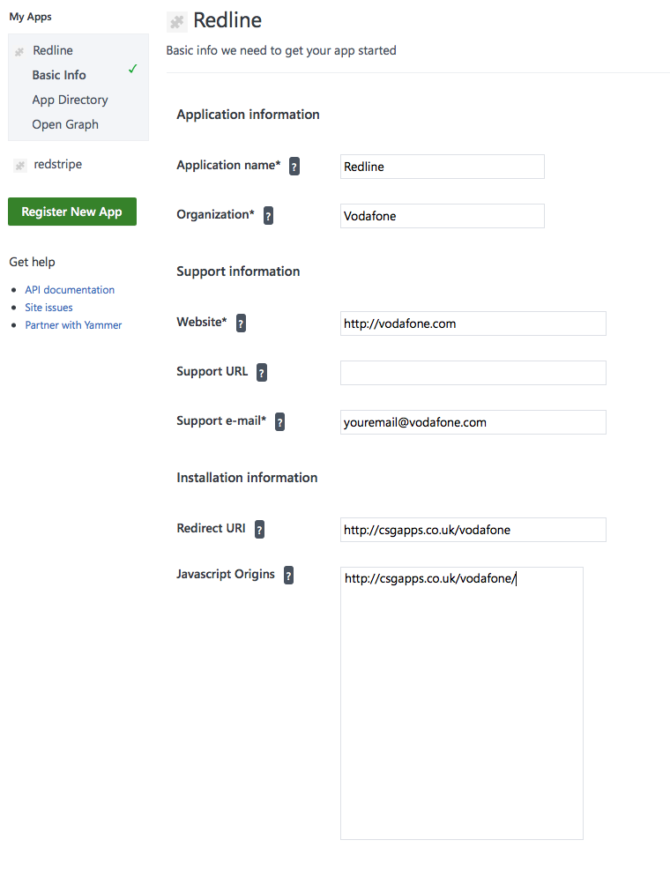

Then, if possible can you create a new yammer group with just yourself in it(for testing) add new group should be in the bottom left hand side.

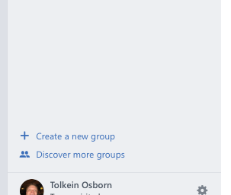

Add the following details, with you being the only member

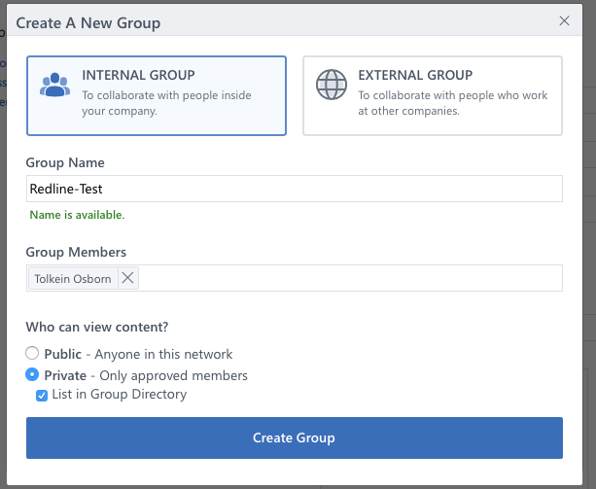

You will then get a box asking you to add other members, just close this. Then you should be presented with a group landing page like the one below

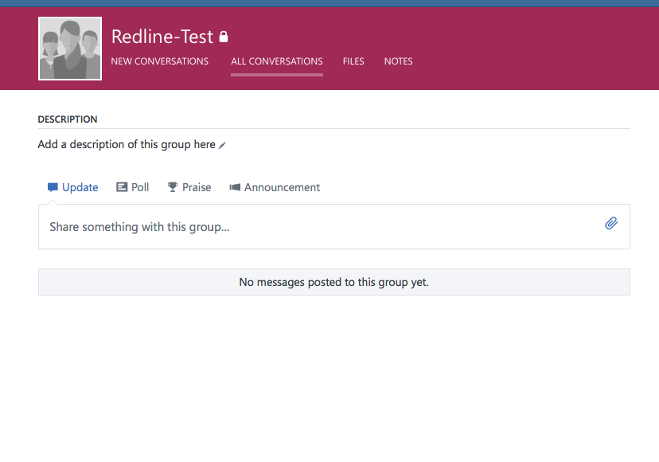

In your browsers url bar you should have a feedid like the one below.

[https://www.yammer.com/csg.com/#/threads/inGroup?type=in_group&feedId=**8683799**&view=all](https://www.yammer.com/csg.com/#/threads/inGroup?type=in_group&feedId=8683799&view=all)

We need the feed id to publish photos just to this group for testing we also need the id for the actual redline group for when the site goes live.

If you have any questions just give us a call.